Properties and functions of cells answer sheets
Activity A: Movement within living cells
- Make a drawing of each organism, label all the parts that can be clearly identified.
Amoeba
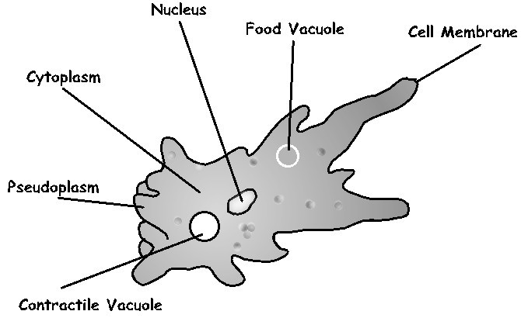
Elodea
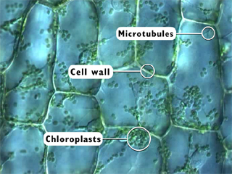
- Which organism above can carry out photosynthesis?
Elodia organism
- Photosynthesis takes place in which organelle?
Chloroplast
- Which organism has a cell wall?
Elodea
- Which of the organisms exhibited movement of the cytoplasm?
Amoeba
- Some of the organisms can secure food by surrounding their prey with cell extensions that ultimately bring the food into the cell. This is called phagocytosis. Which organism can utilize phagocytosis for feeding?
Amoeba
Explain your answer
Amoeba are known as protists found in water and depend on phagocytosis for feeding. Amoebae has a cell membrane that allows selective reabsorption of food materials during phagocytosis.
- Cytoplasm and the organisms within the cells are changing position. Which organelles moved in amoeba? Food vacuole, contractile vacuole and nucleus
Which organelles moved in elodea?
Chloroplast and mitochondria
Activity B: Molecules in motion
- Describe the activity of carmine powder particles in the water
In presence of carmine particles, water droplets are in a continuous dancing as well as vibrating motion. Carmine powder also contains particles that bounces off the molecules of water. This aspect causes water molecules move constantly bumping and colliding with any floating material present.
- Since carmine particles are not alive, what would be causing the carmine powder particles to move?
carmine powder particles move since gases and liquid molecules are always in motion due to diffusion.
Activity C: diffusion and Osmosis
- Initial weight of the dialysis tubing bag
Used to investigate osmosis as well as the potential of water.
- Write a hypothesis for this experiment. What do you think will happen to the weight of the bag as it is in the distilled water for 20 minutes?
The hypothesis of the experiment mentioned above is to investigate cell membrane permeability to different types of sugar. The weight of the bag will increase after 20 minutes. This aspect will indicate osmosis taking place.

